**Prediction of Glucose Level using Perceptron Learning Algorithm**

We have conducted tests on 118 patients using our sensor and have diligently recorded the data. In the dataset there are two columns, named “Time (sec.)” and “Glucose Level (mg/dL)”. Our main objective is to accurately predict the glucose level from the input parameter “Time (sec.)” by using machine learning model. Based on the prediction we can classify the glucose level into three classes: -

1. Severe [ Glucose Level (mg/dL) > 190]
2. Medium [ 160 < Glucose Level (mg/dL) <= 190]
3. Normal [ Glucose Level (mg/dL) <= 160]

In order to train the models, first we need to know whether the data points are linearly separable or not. Therefore, we have pre-processed the data and have created a scatter plot using matplot library in Python.

From the scatter plot (Figure 1) it is evident that the three classes are linearly separably and so we have implemented Perceptron Learning Algorithm to predict the outcome.

1. **Perceptron Learning Model as A Regressor**

$Let us transform the input \hat{x} ∈R^{d} to \hat{x}∈R^{d+1},$ $by {\left(x\right)}^{T}=\left( {1,x}^{T}\right)$

$$∴Format of data: \left\{\left({\hat{x}}_{n},y_{n}\right) | n = 1, 2, … N\right\}, where {\hat{x}}_{n}∈ R^{d+1}$$

$Let, f\left({\hat{x}}_{n}\right)=w_{0}x_{0 }+w_{1}x_{1}+…+w_{d}x_{d },where w^{T}=\left[\begin{matrix}w_{0} & … & w_{d}\end{matrix}\right]$

$$∴f\left(\hat{x}\right)=w^{T}{\hat{x}}_{n}$$

$$Squared {Error for {\hat{x}}_{n}: s.e=\left(w^{T}{\hat{x}}_{n}-y_{n}\right)}^{2}$$

$$Mean Squared Error (MSE)=\frac{1}{N} \sum_{n=1}^{N}{{\left(w^{T}{\hat{x}}_{n}-y_{n}\right)}^{2}}=\frac{1}{N} {\left\|Xw-Y\right\|}^{2}$$

$$For minimum M.S.E, ∇MSE\left(w\right)=\frac{2}{N}X^{T}\left(Xw-Y\right)=0$$

$$∴w={\left(X^{T}X\right)}^{-1}X^{T}Y$$

After training our model, we have obtained $w=\left[\begin{matrix}261.265 & -7.346\end{matrix}\right]$

and out-sample error (M.S.E) as 4.651. The plot of actual vs predicted glucose level is shown in (Figure 2).

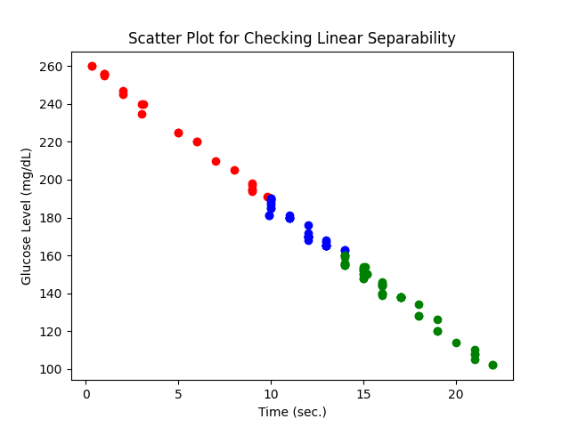

Figure 1: Scatter Plot for Checking Linear Separability

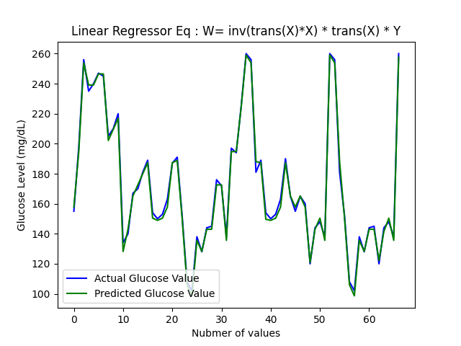

Figure 2: Actual Vs Predicted Glucose Level Prediction